Organic Chemistry – Specific Name Reactions

Class XII

## Sandmeyer Reaction

The Cl, Br and CN nucleophiles can easily be introduced in the benzene ring of benzene diazonium salt in the presence of Cu(I) ion. This reaction is called Sandmeyer reaction.

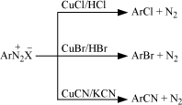

### Gatterman Reaction

Chlorine or bromine can be introduced in the benzene ring by treating the benzene diazonium salt solution with corresponding halogen acid in the presence of copper powder. This is referred as Gatterman reaction.

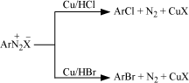

**Note:** The yield in Sandmeyer reaction is found to be better than Gattermann reaction.

### Wurtz Reaction

Alkyl halides react with sodium in dry ether to give hydrocarbons containing double the number of carbon atoms present in the halide. This reaction is known as Wurtz reaction.



### Wurtz-Fittig Reaction

A mixture of an alkyl halide and aryl halide gives an alkylarene when treated with sodium in dry ether and is called Wurtz-Fittig reaction.



### Fittig Reaction

Aryl halides also give analogous compounds when treated with sodium in dry ether, in which two aryl groups are joined together. It is called Fittig reaction.



### Friedel-Crafts alkylation Reaction

When benzene is treated with an alkyl halide in the presence of anhydrous aluminium chloride, alkylbenene is formed.

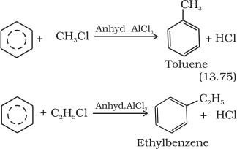

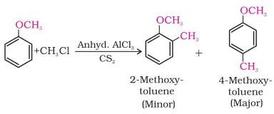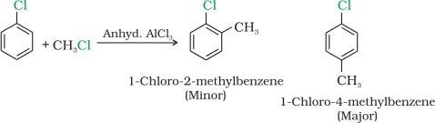

**Note:** Aromatic carboxylic acids do not undergo Friedel-Crafts reaction because the carboxyl group is deactivating and the catalyst aluminium chloride (Lewis acid) gets bonded to the carboxyl group.

### Friedel-Crafts acylation reaction

The reaction of benzene with an acyl halide or acid anhydride in the presence of Lewis acids (AlCl3) yields acyl benzene.

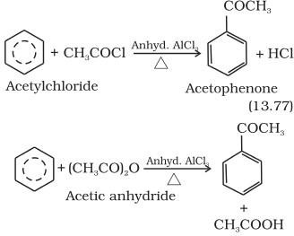

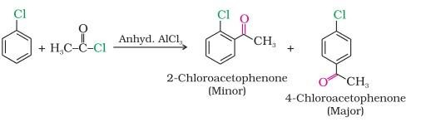

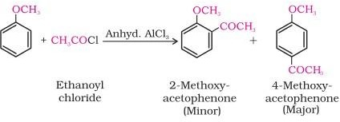

### Reimer-Tiemann Reaction

On treating phenol with chloroform in the presence of sodium hydroxide, a –CHO group is introduced at ortho position of benzene ring resulting salicylaldehyde. This reaction is known as Reimer - Tiemann reaction.

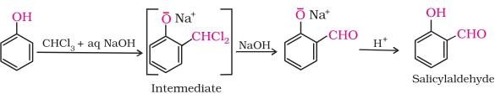

### Kolbe’s Reaction

Phenol with sodium hydroxide gives sodium phenoxide ion which with carbon dioxide in acidic medium results hydroxybenzoic acid (salicylic acid). This is known as Kolbe’s reaction.

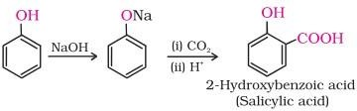

### Rosenmund Reduction

Acyl chloride (acid chloride) is hydrogenated over catalyst, palladium on barium sulphate. This reaction is called Rosenmund reduction.

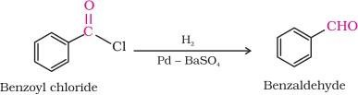

### Gatterman – Koch reaction

When benzene or its derivative is treated with carbon monoxide and hydrogen chloride in the presence of anhydrous aluminium chloride or cuprous chloride, it gives benzaldehyde or substituted benzaldehyde. This reaction is known as Gatterman-Koch reaction.

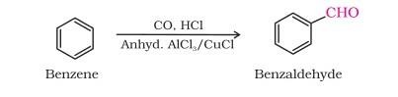

### Clemmensen Reduction

The carbonyl group of aldehydes and ketones is reduced to CH2 group on treatment with zinc- amalgam and concentrated hydrochloric acid. This is known as Clemmensen reduction.



### Wolff Kishner Reduction

The carbonyl group of aldehydes and ketones is reduced to CH2 group on treatment with hydrazine followed by heating with sodium or potassium hydroxide in high boiling solvent such as ethylene glycol. This is known Wolff Kishner reduction.



### Tollens’ test

On warming an aldehyde with freshly prepared ammoniacal silver nitrate solution (Tollens’ reagent), a bright silver mirror is produced due to the formation of silver metal. The aldehydes are oxidised to corresponding carboxylate anion. The reaction occurs in alkaline medium.

### Fehling’s test

Fehling reagent comprises of two solutions, Fehling solution A and Fehling solution B. Fehling solution A is aqueous copper sulphate and Fehling solution B is alkaline sodium potassium tartarate (Rochelle salt). These two solutions are mixed in equal amounts before test. On heating an aldehyde with Fehling’s reagent, a reddish brown precipitate is obtained. Aldehydes are oxidised to corresponding carboxylate anion. Aromatic aldehydes do not respond to this test.



### Aldol reaction

Aldehydes and ketones having at least one α-hydrogen undergo a reaction in the presence of dilute alkali as catalyst to form β-hydroxy aldehydes (aldol) or β-hydroxy ketones (ketol), respectively. This is known as **Aldol reaction**. The name aldol is derived from the names of the two functional groups, aldehyde and alcohol, present in the products.

### Aldol condensation.

The aldol and ketol readily lose water to give α,β-unsaturated carbonyl compounds which are aldol condensation products and the reaction is called **Aldol condensation**.

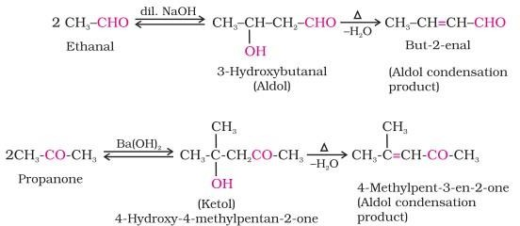

### Cross aldol condensation:

When aldol condensation is carried out between two different aldehydes and / or ketones, it is called cross aldol condensation. If both of them contain α-hydrogen atoms, it gives a mixture of four products.



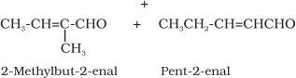

### Cannizzaro reaction:

Aldehydes which do not have an α-hydrogen atom, undergo self oxidation and reduction (disproportionation) reaction on treatment with concentrated alkali. In this reaction, one molecule of the aldehyde is reduced to alcohol while another is oxidised to carboxylic acid salt.

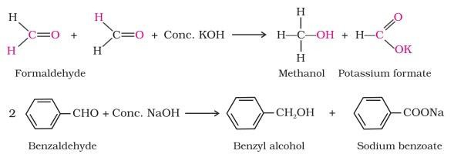

### Kolbe electrolysis

An aqueous solution of sodium or potassium salt of a carboxylic acid on electrolysis gives alkane containing even number of carbon atoms.It is decarboxylation reaction. The reaction is known as Kolbe electrolysis.

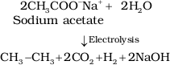

### Hell-Volhard-Zelinsky (HVZ )reaction.

Carboxylic acids having an α-hydrogen are halogenated at the α-position on treatment with chlorine or bromine in the presence of small amount of red phosphorus to give α-halocarboxylic acids. The reaction is known as Hell- Volhard-Zelinsky reaction.

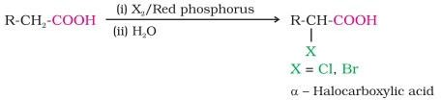

### Hoffmann bromamide degradation reaction

An amide with bromine in an aqueous or ethanolic solution of sodium hydroxide gives primary amines.

In this degradation reaction, migration of an alkyl or aryl group takes place from carbonyl carbon of the amide to the nitrogen atom. The amine so formed contains one carbon less than that present in the amide.



### Carbylamine reaction

Aliphatic and aromatic primary amines on heating with chloroform and ethanolic potassium hydroxide form isocyanides or carbylamines which are foul smelling substances. This reaction is known as carbylamines reaction or isocyanide test.



**Note:** Secondary and tertiary amines do not show this reaction and is used as a test for primary amines.

### Coupling Reactions:

Benzene diazonium chloride reacts with phenol in which the phenol molecule at its para position is coupled with the diazonium salt to form p-hydroxyazobenzene. This type of reaction is known as coupling reaction.

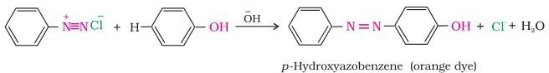

Similarly the reaction of diazonium salt with aniline yields p-aminoazobenzene

1. **Diazotization reaction**

Diazotization Reaction involves the formation of diazonium salts when aromatic amines are made to react with nitrous acid in presence of mineral acid at 0 to 5 ◦c.

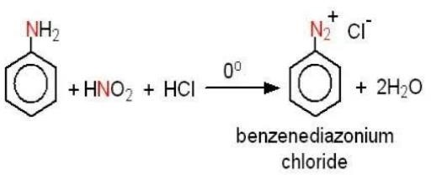

# Perkin condensation

The Perkin reaction, also known as Perkin condensation, is an organic reaction which is used for the synthesis of α,β-unsaturated aromatic acid by the condensation of an aromatic aldehyde and an acid anhydride having alpha hydrogen atom, in the presence of salt of the parent carboxylic acid.

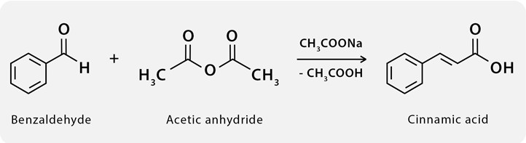

## Benzoin Condensation

The Benzoin Condensation is a coupling reaction between two aldehydes that allows the preparation of α- hydroxyketones.

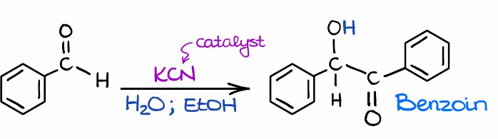

# Claisen Condensation

It involves self-condensation of two molecules of ester containing alpha-hydrogen in the presence of a strong base such as sodium ethoxide to form beta-keto ester.

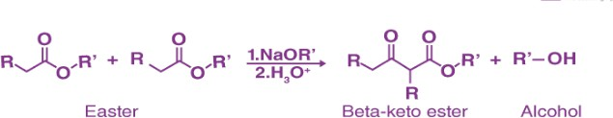

# Ozonolysis

When an alkene reacts with ozone in an inert solvent (ether, CCl4etc.), an explosive and unstable ozonide

is formed. The ozonide undergoes hydrolysis producing carbonyl compounds. These two processes, the addition of O3 and hydrolysis are collectively called ozonolysis.

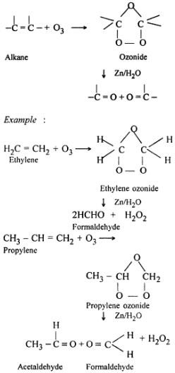

# 2,4 DNP Test

Aldehyde and ketones react with 2,4-dinitrophenylhydrazine to give aldehyde or ketone – 2,4- dinitrophenlhydrazone which is yellow or orange ppt.

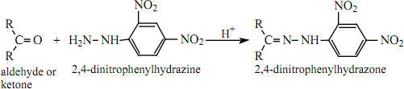

# Iodoform Test

Aldehydes, ketones having methyl ketonic group react with iodine in the presence of sodium hydroxide to give iodoform indicated by yellow crystalline solid having hospital like smell. Alcohols which on oxidation gives methyl ketonic group also gives this test.

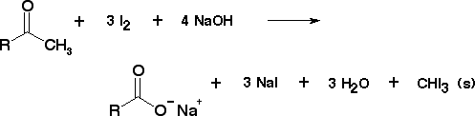

# Kolbe’s reaction (carboxylation)

Sodium phenoxide reacts with carbon dioxide gas at about 125oC and 4 to 7 atm to give sodium salicylate which on acidification with dilute HCl gives salicylic acid.

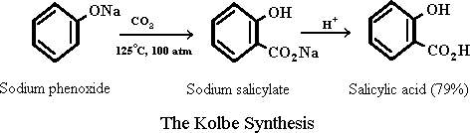

# Lucas Test

Haloalkanes react with conc HCl in the presence of anhydrous zinc chloride, commonly known as Lucas reagent, to give white ppt of haloalkane. Reactivity of haloalkanes follows the sequence: tertiary > secondary > primary.

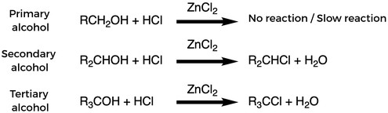

# Williamson Ether synthesis

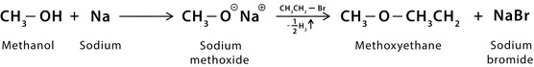Sodium ethoxide reacts with haloalkane to give an ether.

# Hydroboration Oxidation

Alkene reacts with borane to give trialkyl borane which on hydrolysis gives primary alcohol.

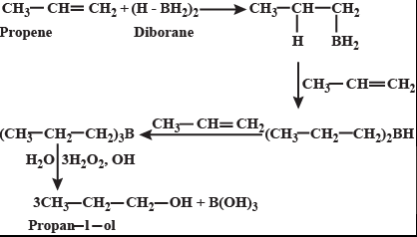

# Oxo Process

Alkene reacts with carbon monoxide and hydrogen gas in the presence of catalyst like dicobalt octacarbonyl at high temperature and pressure to give an aldehyde which on reduction gives primary alcohol.

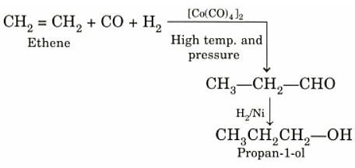

# Hoffman's Ammonolysis

Haloalkanes react with ammonia in the presence of alcohol at about 100oC to give the mixture of 1o, 2o,3o amine along with quaternary ammonium salt.

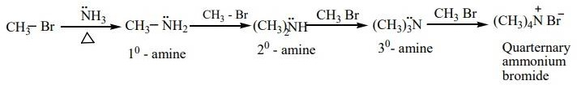

# Esterification

Carboxylic acid reacts with alcohol in the presence of conc sulphuric acid to give an ester. It’s a reversible reaction.

